5. GOVERNMENT MONITOR PAGE:
5.1 Global Controls & Hero Section — Technical Summary:
Purpose
The Global Controls & Hero Section functions as the orchestration layer of the Government Monitor dashboard. It defines the active territory (APAC or specific country) and data authority (Internal vs External benchmarks), ensuring that all downstream components—Readiness Map, Leaderboard, Compliance Matrix—operate within the selected context. It provides immediate scope visibility (total domains tracked) and enables generation of executive-level strategic briefings.
Dataset Source
Database: apac_ipv6_hub
gov_domains
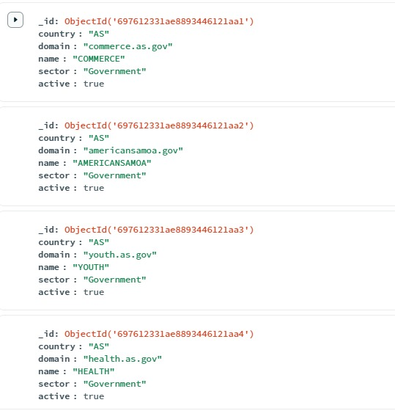

gov_scans
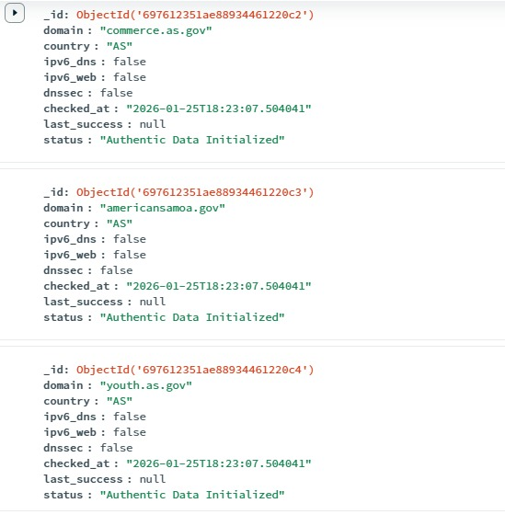

external_ipv6_stats
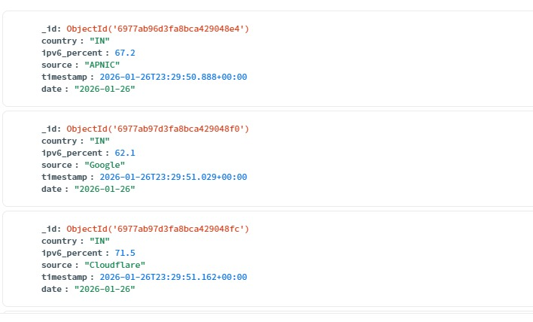

apac_country_codes
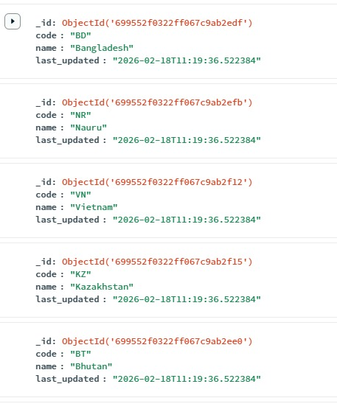

Internal Tactical Data:
Collection | Role
gov_domains | Master registry of government domains
gov_scans | Technical audit results (IPv6 DNS, Web, DNSSEC)
apac_country_codes | ISO country mapping
External Benchmarks (Cached):
Source | Stored In
APNIC Labs | external_ipv6_stats
Google | external_ipv6_stats
Cloudflare Radar | external_ipv6_stats

Input Mechanisms:
A. Territory Filter (#gov-country-select)
- Default: ALL (APAC)
- Appends ?country=XX to API calls
- Triggers:
  - Map zoom
  - Stats refresh
  - Leaderboard update
B. Data Authority Toggle (#gov-data-source)
- Internal Metrics (Live) → Uses gov_scans
- External Mode → Uses external_ipv6_stats
Frontend switches rendering logic based on selection.
Processing Workflow:
When a country is selected:
- Frontend triggers loadGovResults().
- Backend runs MongoDB aggregation:
db.gov_scans.aggregate([
{ $match: { country: "IN" } },
{ $sort: { checked_at: -1 } },
{ $group: { _id: "$domain", latest: { $first: "$$ROOT" } } }
])
- Ensures:
  - Only latest scan per domain is used.
  - No duplicate domain counting.
- UI updates:
  - Total domain count
  - Compliance percentages
  - Map boundaries

Formula Used (Internal Readiness Score):
Step 1 — Calculate Percentages
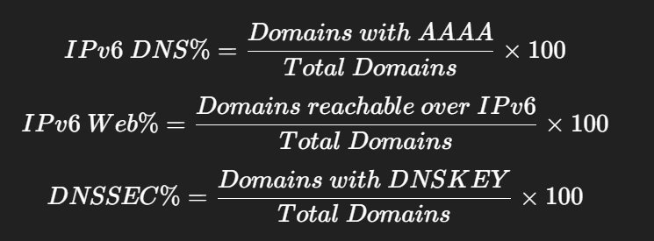

Step 2 — Weighted Score
$$Score=(DNS\%×0.4)+(Web\%×0.4)+(DNSSEC\%×0.2)$$
Example — India
Given:
- Total domains = 150
- IPv6 DNS ready = 140
- IPv6 Web reachable = 100
- DNSSEC enabled = 20
Percentages:
$$DNS\%=140/150×100=93\% \\ Web\%=100/150×100=67\% \\ DNSSEC\%=20/150×100=13\%$$
Score:
$$Score=(93×0.4)+(67×0.4)+(13×0.2) \\ =37.2+26.8+2.6=66.6$$
Displayed as:
66.6 → MODERATE
Total Domains Tracked Calculation
$$Unique_Domains=count(distinct(domain))$$Ensures no double-counting of re-scanned domains.
Strategic Briefing Output
Clicking “Briefing”:
- Calls /api/analytics/report/generate
- Uses:
  - Current readiness score
  - Leaderboard top 10
  - Technical recommendations
- Generated via PDFService (ReportLab)
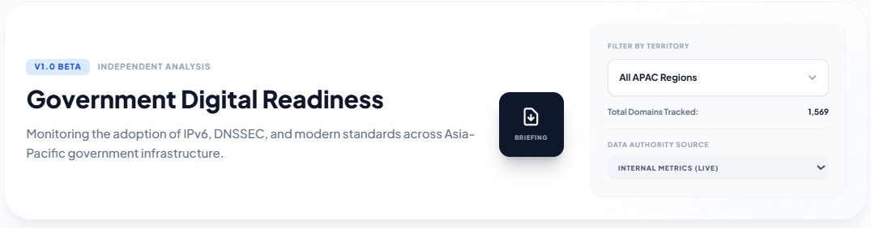
Snippet

5.6 Interactive Readiness Map — Technical Summary
Purpose
The Interactive Readiness Map provides a spatial visualization of IPv6 and DNSSEC maturity across APAC economies. It transforms country-level technical audit metrics into a normalized readiness score (0–100) and maps them onto GeoJSON boundaries, allowing policymakers to instantly identify leaders, laggards, and regional readiness clusters.
Dataset Source
Database: apac_ipv6_hub

gov_scans


apac_ipv6_normalized
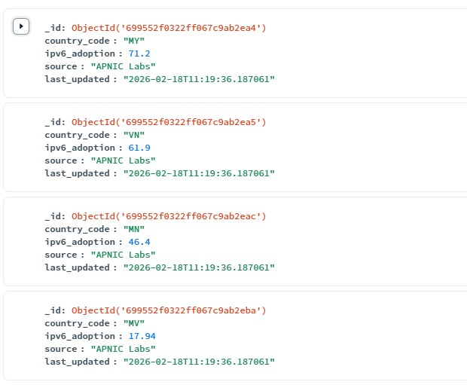

Internal Mode (Live Tactical Scans):
Collection | Role
gov_scans | Stores IPv6 DNS, Ipv6 Web, DNSSEC scan results
gov_domains | Domain registry per country
Accessed via:
“/gov-monitor/api/stats”
External Benchmark Mode
Collection | Role
apac_ipv6_normalized | Official adoption % (APNIC/Google/Cloudflare)
Geometry Source:
File | Role
countries.geo.json | Geo-boundaries indexed by ISO_A2 / ISO_A3
Input Mechanisms:
Input | Effect
Territory Filter | Filters score by country
Authority Toggle | Switches between internal vs external data
Hover | Displays score + classification
Click | Updates global country state

Score Calculation (Internal Mode):
Step 1 — Compute Percentages:
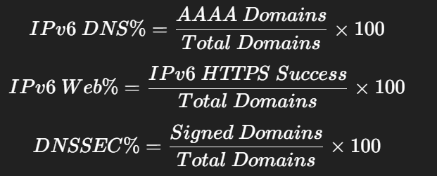
Step 2 — Weighted Readiness Score
$$Score=(DNS\%×0.4)+(Web\%×0.4)+(DNSSEC\%×0.2)$$Result is:
- Rounded to 1 decimal place
- Constrained to 0–100 range
Example Calculation
Suppose Malaysia has:
- Total Domains = 200
- AAAA Ready = 180
- IPv6 Web Reachable = 150
- DNSSEC Signed = 40

Percentages:
$$DNS\%=180/200×100=90\% \\ Web\%=150/200×100=75\% \\ DNSSEC\%=40/200×100=20\%$$
Final Score:
$$Score=(90×0.4)+(75×0.4)+(20×0.2) \\ =36+30+4=70$$
Displayed as:
70.0 → Advancing
Classification Scale:
Score Range | Level | Meaning
≥ 90 | Leader | Full-stack adoption
≥ 75 | High | Strong readiness
≥ 60 | Advancing | Significant progress
45–59 | Moderate | Basic IPv6
30–44 | Developing | Early rollout
15–29 | Low | Fragmented
0–14 | Critical | Ipv4-dominant
-1 | No Data | Not found
Inclusive lower bounds used.
Example:
- 60.0 → Advancing
- 59.9 → Moderate
How Map Rendering Works:
- Frontend fetches country scores.
- For each GeoJSON feature:
styleFeature(feature)
- Country ISO code is matched to score.
- Color assigned based on classification threshold.
- Tooltip displays:
  - Economy Name
  - Score
  - Level
If no data found:
Score = -1 → Gray (#f1f5f9)
External Mode Formula:
When authority is switched:
$$Score=ipv6_adoption (from apac_ipv6_normalized)$$
No weighting applied. Value plotted directly.
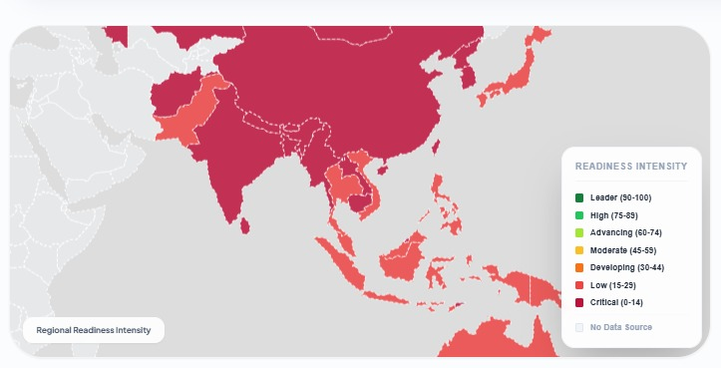
Snippet

Adoption Trend Chart — Technical Summary
Purpose
The Adoption Trend Chart provides a time-series view of IPv6 government readiness, enabling analysts to measure migration velocity, detect infrastructure regressions, and evaluate policy effectiveness over time. It converts daily tactical scan results into a chronological readiness percentage (0–100%) to identify growth, stagnation, or decline.
Dataset Source:
Database: apac_ipv6_hub
Collection: history_logs
history_logs
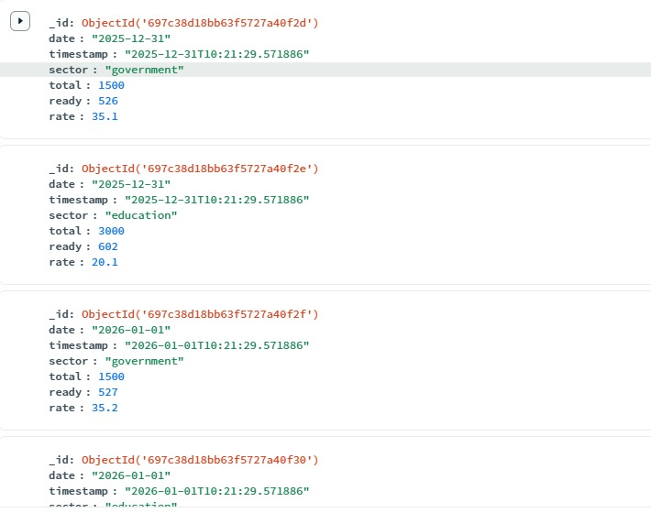

Filtering Conditions:
Field | Condition
sector | “government”
country | Optional (ISO code)
date | Sorted ascending
Snapshots are created via:
APACDomainMonitorService.save_history()
Each document contains:
{
"date": "YYYY-MM-DD",
"sector": "government",
"ready": <int>,
"total": <int>,
"rate": <float>
}
Input Mechanism:
Input | Effect
Country Filter | /gov-monitor/api/history?country=XX
All Regions | Aggregated regional history
Date Window | Last 90 days
Processing & Formula:
Step 1 — Ready Definition
A domain is marked Ready only if:
ipv6_dns = true AND ipv6_web = true
Partial domains are excluded.

Step 2 — Daily Readiness Rate
$$Rate=\left(\frac{Ready_Domains}{Total_Domains}\right)×100$$
Rounded to 1 decimal place.

Step 3 — Regional Aggregation (All Regions)
$$Regional Rate=\left(\frac{∑Ready_{i}}{∑Total_{i}}\right)×100$$
(Important: It sums raw counts first, then computes percentage — not an average of country rates.)
Example Calculation:
Given:
- Total Domains = 100
- Ready Domains = 35
$$Rate=(35/100)×100=35.0$$
Stored as:
{
“date”: “2026-02-25”,
“ready”: 35,
“total”: 100,
“rate”: 35.0
}
UI plots:
- X-axis → Date
- Y-axis → 35.0
If previous value = 20.0:
$$Growth=35.0-20.0=+15.0$$
Triggers:
Positive Growth
Chart Output
Axis | Meaning
X-axis | Date
Y-axis | Readiness % (0–100)
Line Type | Continuous (tension 0.4)

Snippet
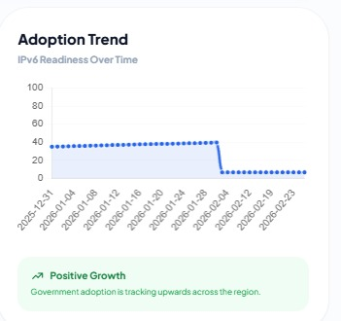

IPv6 Web Reachable (%) — Technical Summary
Purpose
The IPv6 Web Reachable (%) KPI measures the percentage of government domains that successfully complete an HTTPS connection over IPv6. It validates true service availability over IPv6 (not just DNS advertisement), confirming that websites are operational and reachable in real-world IPv6 environments.
Dataset Source
Discovery Layer
- datasets/apac_gov_domains.json
- or MongoDB collection: gov_domains

gov_domains


Scan Results (Primary Source)
- MongoDB collection: gov_scans


- Fallback: data/apac_gov_ipv6_results.json
Generated by
- APACDomainMonitorService (live tactical scanner)
Input Parameters:
For each domain:
- domain (FQDN)
- country (ISO-A2)
- timeout = 2.0s

Processing Logic:
Step 1 — AAAA Resolution
Resolve IPv6 address:
dns.resolver.resolve(domain, 'AAAA')
If no AAAA → marked as failure.
Step 2 — TCP Connection (IPv6)
Create socket:
socket.AF_INET6
Attempt connection to:
port 443
Step 3 — TLS Handshake
Wrap socket with:
ssl.create_default_context()
context.wrap_socket(..., server_hostname=domain)
If handshake completes without exception:
ipv6_web = True
Else:
ipv6_web = False
No retries per scan cycle.
Mathematical Formula:
Let:
- N = Total monitored domains
- W = Domains where ipv6_web = True
$$IPv6 Web Reachable\%=\left(\frac{W}{N}\right)×100$$
Rounded using:
$$Math.round()$$
Example Calculation (UI shows 7%)
Given:
- Total Domains (N) = 200
- Successful IPv6 HTTPS (W) = 14
$$(14/200)×100=7.0\%$$
Displayed as:
7%
Edge Case Handling:
Scenario | Behavior
No AAAA record | Web probe skipped → counts as 0
Port 443 blocked | Timeout → False
TLS version mismatch | Handshake fails → False
Expired certificate | Handshake completes → True
Shadow IPv6 | AAAA exists but handshake fails → False
DB down | Fallback to last JSON snapshot
Failures are counted conservatively as non-reachable.
Snippet:
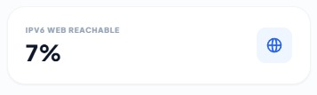

IPv6 DNS Ready (%) — Technical Summary
Purpose
The IPv6 DNS Ready (%) KPI measures the percentage of monitored government domains that publish a valid IPv6 address (AAAA record) in DNS. It confirms that domains are globally addressable via IPv6 — the foundational step of IPv6 adoption — regardless of whether the web service itself is operational.
Dataset Source
Database: apac_ipv6_hub (MongoDB)
gov_domains


gov_scans


Collection | Role
gov_domains | Master list of tracked government domains
gov_scans | Stores latest DNS resolution results
Execution Engine: APACDomainMonitorService
Library Used: dnspython
Input Parameters:
For each domain:
- domain (FQDN)
- record_type = AAAA
- lifetime = 2.0 seconds (DNS timeout)

Processing Logic:
Step 1 — AAAA Query
dns.resolver.resolve(domain, 'AAAA', lifetime=2)
Step 2 — Result Interpretation
- If at least one IPv6 address returned →
ipv6_dns = True
- If NXDOMAIN / NoAnswer / Timeout →
ipv6_dns = False
Each result is persisted in gov_scans with:
- ipv6_dns
- checked_at
- status
Only the latest scan per domain is used for KPI calculation.
Mathematical Formula:
Let:
- N = Total monitored domains
- D = Domains where ipv6_dns = True
$$IPv6 DNS Ready\%=\left(\frac{D}{N}\right)×100$$
Rounded using:
$$Math.round()$$ Example Calculation (UI shows 8%)
Given:
- Total Domains (N) = 100
- Domains with AAAA record (D) = 8
$$(8/100)×100=8.0\%$$

Displayed as:
8%
Service Classification Logic:
Condition | Classification
ipv6_dns = False | No-IPv6
ipv6_dns = True & ipv6_web = False | Shadow-Ipv6
Both True | Full-Stack
Failure Handling:
Scenario | Behavior
NXDOMAIN | Counts as False
No AAAA record | False
DNS Timeout | False
Scan exception | Placeholder record with False
Database unavailable | Fallback to cached results
Failures are conservatively counted as non-ready.
Snippet:

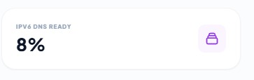

Secure (DNSSEC) (%) — Technical Summary
Purpose
The Secure (DNSSEC) (%) KPI measures the percentage of monitored government domains that have DNSSEC enabled and cryptographically signed. It verifies domain integrity and origin authentication, protecting against DNS spoofing, cache poisoning, and redirection attacks. DNSSEC contributes 20% weight to the overall internal readiness score.
Dataset Source
Database: apac_ipv6_hub
gov_domains


gov_scans


Collection | Role
gov_domains | Master list of tracked domains
gov_scans | Stores latest DNSSEC validation result (dnssec: true/false)
Execution Engine: APACDomainMonitorService
Library Used: dnspython
Input Parameters:
For each domain:
- domain (FQDN)
- record_types = DNSKEY, DS
- resolver_timeout = 2.0s
Processing Logic:
Step 1 — DNSKEY Lookup
dns.resolver.resolve(domain, 'DNSKEY')
If DNSKEY exists → zone is signed candidate.
Step 2 — DS Record Validation (Chain of Trust)
Parent zone DS record checked to confirm linkage to root.
Step 3 — Signature Indicators
System verifies presence of:
- RRSIG (signed records)
- NSEC/NSEC3 (authenticated denial)
If validation passes:
dnssec = True
Else:
dnssec = False
Only the latest scan per domain is used in KPI calculation.
Mathematical Formula
Let:
- N = Total monitored domains
- S = Domains where dnssec = True
$$Secure (DNSSEC)\%=\left(\frac{S}{N}\right)×100$$
Rounded using:
$$Math.round()$$
Example Calculation (UI shows 11%):
Given:
- Total Domains (N) = 300
- DNSSEC Signed Domains (S) = 33
$$(33/300)×100=11.0\%$$
Displayed as:
11%
Weighted Contribution to Readiness Score
DNSSEC contributes 20% to the composite readiness metric:
$$Score=(DNS\%×0.4)+(Web\%×0.4)+(DNSSEC\%×0.2)$$
Unsigned domains reduce both:
- DNSSEC KPI
- Overall Readiness Score
Failure Handling
Scenario | Behavior
No DNSKEY | dnssec = False
No DS record | Treated as insecure
Expired signature | False
Broken chain | False
Timeout | False
Validation error | False
System follows conservative security posture.

Snippet

ISP Infrastructure Distribution — Technical Summary
Purpose
The ISP Infrastructure Distribution panel measures the concentration of government domains across hosting providers (ISPs/ASNs). It identifies infrastructure dependency, highlights central points of failure, and reveals migration trends toward cloud or commercial providers. The metric reflects hosting concentration, not protocol readiness.
Dataset Source:
Database: apac_ipv6_hub
Collection: gov_scans
gov_scans


Relevant fields:
- isp (Hosting organization name)
- asn (Autonomous System Number)
- country
- Latest scan per domain (deduplicated)
Data is populated during tactical scans using IP-to-ASN mapping verified against BGP routing data.
Input Logic:
Input | Effect
Territory Filter | Filters domains by ISO country or ALL
Authority Mode | Always internal (tactical data)
Dataset | globalResults (latest scan only per domain)
Unknown ISP values are excluded from ranking but included in total denominator.
Processing Workflow:
- Extract isp field from each domain in selection.
- Exclude "Unknown" for ranking.
- Count frequency:
ISP_Name → Domain_Count
- Sort descending by count.
- Display Top 10 providers.
- Compute percentage share relative to total monitored domains.
Mathematical Formula:
Let:
- T = Total monitored domains in region
- I = Domains hosted on a specific ISP
$$ISP Share\%=\left(\frac{I}{T}\right)×100$$
Rounded using:
$$Math.round()$$
Example Calculation:
Scenario (Regional View):
- Total Domains (T) = 1000
- Domains on “Generic Infra” (I) = 390
$$390/1000=0.39 \\ 0.39×100=39\%$$
Displayed as:
39%
Output Structure:
Each Infrastructure Card displays:
- Provider Name
- Percentage Share
- Indicator Bar
- Tooltip (absolute domain count)
Example Tooltip:
Microsoft hosts 150 government domains.
Edge Case Handling:
Scenario | Behavior
No ISP data | Display fallback message
Multiple scans per domain | Only latest counted
Cloud providers across countries | Aggregated in ALL view
Unknown ISP | Excluded from ranking but included in denominator

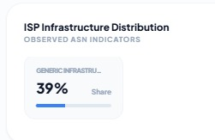
Snippet:

Regional Leaderboard — Technical Summary
Purpose
The Regional Leaderboard ranks APAC economies based on a composite IPv6 Readiness Score, enabling competitive benchmarking and executive-level reporting. It converts domain-level infrastructure metrics into a single weighted score (0–100) and displays the Top 10 performing economies.
Dataset Source
Database: apac_ipv6_hub (MongoDB)
gov_scans


Internal Mode (Default):
Collection | Role
gov_scans | Stores IPv6 DNS, IPv6 Web, DNSSEC results
gov_domains | Total domain count per country
Generated via:
“APACDomainMonitorService.get_detailed_stats()”
External Mode (Optional Toggle):
Pulled from:
/api/analytics/benchmarks
Sources:
- APNIC
- Google
- Cloudflare
Input Mechanisms:
Input | Effect
Authority Switch | Internal vs External scoring
Territory Filter | Regional or drill-down view
Default Scope | Regional Top 10
Processing & Formula (Internal Mode)
For each country:
Let:
- P_DNS = % domains with AAAA record
- P_Web = % domains reachable via IPv6 HTTPS
- P_Sec = % domains signed with DNSSEC
Weighted Readiness Score:
$$Score=(P_{DNS}×0.4)+(P_{Web}×0.4)+(P_{Sec}×0.2)$$
Each percentage is first computed as:
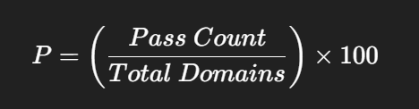

Example Calculation
Country “Alpha”:
- Total Domains = 100
- IPv6 DNS = 70 → 70%
- IPv6 Web = 80 → 80%
- DNSSEC = 50 → 50%
Weighted Score:
$$70×0.4=28 \\ 80×0.4=32 \\ 50×0.2=10 \\ Final Score=28+32+10=70.0$$
Displayed as:
70.0 → MODERATE
Sorting Logic:
Server-side sorting:
country_stats.sort(key=lambda x: x['score'], reverse=True)
- Highest score ranked #1
- Stable sort preserves order for ties
- No skipped ranks
Readiness Classification:
Score | Level
≥ 80 | High
≥ 50 | Moderate
< 50 | Low

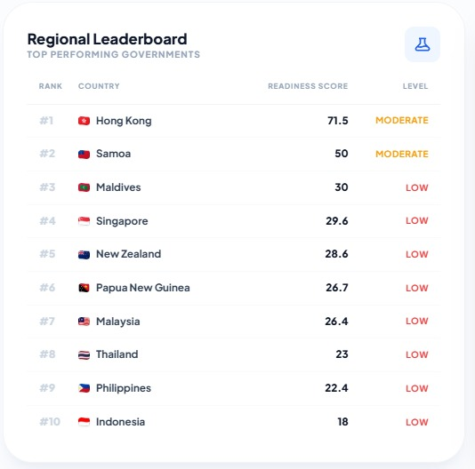
Snippet

Failure Intelligence (Gap Analysis) — Technical Summary
Purpose
The Failure Intelligence module performs a tactical gap analysis by identifying where IPv6 transition failures occur — at the DNS advertisement layer, the IPv6 web reachability layer, or the DNSSEC security layer. Instead of showing readiness, it highlights infrastructure deficiencies so policymakers can prioritize remediation efforts.
Dataset Source
Database: apac_ipv6_hub
Collection: gov_scans



Each document contains:
- ipv6_dns (AAAA presence)
- ipv6_web (HTTPS over IPv6 success)
- dnssec (Signed zone status)
- country
Processing engine:
APACDomainMonitorService._calculate_country_score()
Only the latest scan per domain is used (deduplicated).

Input Logic
Input | Effect
Territory Filter | Regional or country-level aggregation
Default View | Regional aggregate
Dataset | globalResults (latest domain scans)
Processing & Formula:
Let:
- T = Total monitored domains
- P_DNS = Domains passing AAAA
- P_Web = Domains passing IPv6 HTTPS
- P_Sec = Domains passing DNSSEC
Failure (Gap) percentage is calculated as:

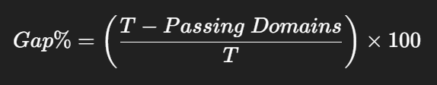

Equivalent to:
$$Gap\%=100-Passing\%$$
Rounded using:
$$Math.round()$$ Example Calculation:
Scenario:
- Total Domains (T) = 1000
- Missing AAAA = 600
- Web Failures = 800
- Missing DNSSEC = 400
Missing DNS:
$$(600/1000)×100=60\%$$
Web Unreachable:
$$(800/1000)×100=80\%$$

Missing DNSSEC:
$$(400/1000)×100=40\%$$
Displayed as:
- 60% (Red)
- 80% (Amber)
- 40% (Purple)
Severity Classification:
Gap % | Severity
> 50% | Critical
30–50% | High Concern
15–30% | Moderate
< 15% | Minor
Insight text dynamically generated based on the dominant failure mode.

Snippet
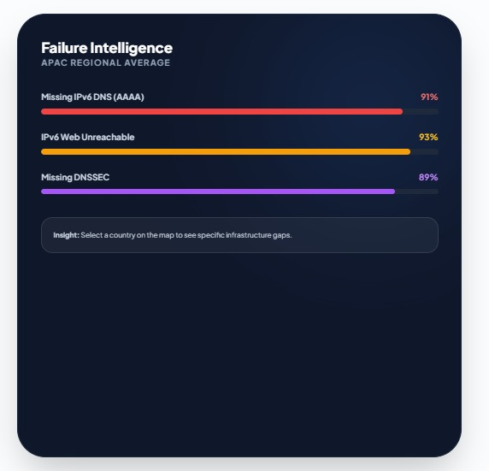

Compliance Matrix (Domain Table) — Technical Summary
Purpose
The Compliance Matrix provides domain-level forensic transparency of IPv6 compliance. It shows the exact technical status of each monitored government domain (DNS, Web, DNSSEC, latency), enabling audit verification and root-cause analysis of infrastructure gaps.
Dataset Source
Database: apac_ipv6_hub
Collection: gov_scans



Query Logic
MongoDB aggregation retrieves:
- Latest record per domain
- Based on highest checked_at timestamp
Example aggregation:
[
{ $sort: { checked_at: -1 } },
{ $group: { _id: "$domain", latest: { $first: "$$ROOT" } } }
]

Input Mechanisms:
Input | Effect
Territory Filter | Filters domains by ISO country
Text Search | Real-time client filter
Pagination | 20 records per page
Authority Mode | Internal (tactical scan only)
Processing Logic:
For each domain, the scanner performs:
A. IPv6 DNS Test:
AAAA lookup:
$$ipv6_dns=True\text{ if AAAA record exists}$$
B. IPv6 Web Test
HTTPS handshake over IPv6:
$$ipv6_web=True\text{ if TLS handshake succeeds}$$
C. DNSSEC Test
DNSKEY/DS validation:
$$dnssec=True\text{ if signed zone detected}$$
D. RTT Efficiency
Measure connection latency:
$$Delta=RTT_{IPv6}-RTT_{IPv4}$$
Displayed for comparison (not used in classification).
Status Classification Formula:
Status | Condition
READY | ipv6_dns = True AND ipv6_web = True
PARTIAL | ipv6_dns = True AND ipv6_web = False
NOT READY | ipv6_dns = False
DNSSEC does not affect READY classification.
Example Calculation:
Domain: mfa.gov.af
- AAAA Found → True
- HTTPS over IPv6 → True
- DNSSEC → False
- IPv4 RTT = 210.55ms
- IPv6 RTT = 1836.21ms
Classification:
$$READY$$
Because:
$$ipv6_dns=True\text{AND}ipv6_web=True$$
Latency difference does not change status.
Formula Used (Per-Domain):
There is no percentage formula per row.
Status is determined by Boolean logic:
$$Status=f(ipv6_dns,ipv6_web)$$
Snippet
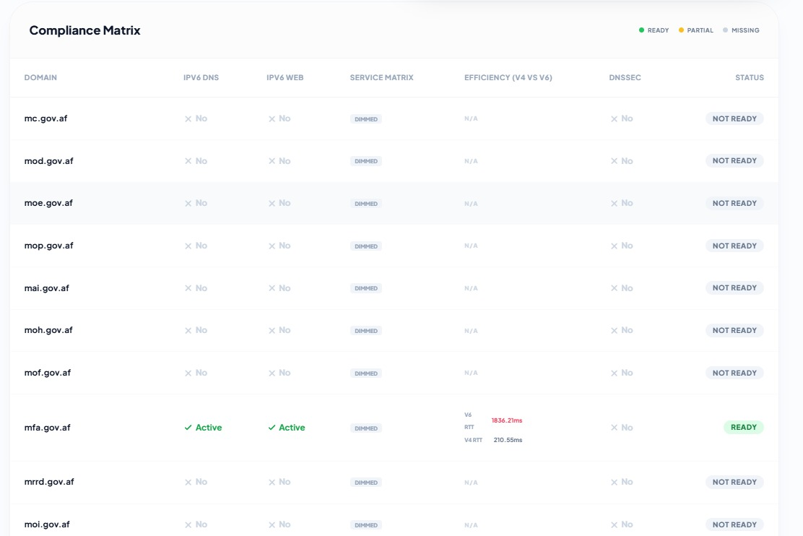

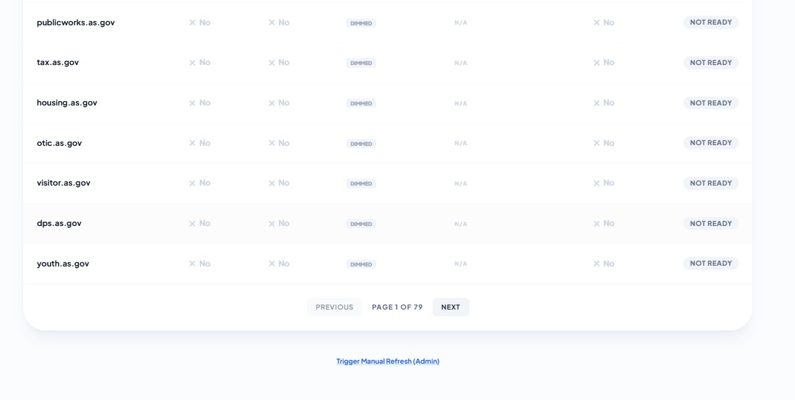

Overall:
